**WEEK 1**

**Class 1**

Lectures

* Lecture 1- Introduction
* Lecture 1- Business Plan

To Do

* ICA 1
* Go over Syllabus
* Do a walk though what are the fundamental elements of business
  + HR, Strategic Management, Accounting, Finance (real estate)
    - You will do all of these when you start your company
  + Everyone write on board one business concept
* Introductions
* Small Business

**Class 2**

Business Plans

ICA 2

**WEEK 2**

**Class 3**

Overview what we did and will be doing

Go over Project

* Layout
* Purpose
* Idea
* Teams

Feasibility

Financials

Two Videos

<https://www.youtube.com/watch?v=UUzvo4HwojU> -peter

<https://www.youtube.com/watch?v=2lcp0uZsY7k> –paul

**IDEA**

Raspberry Protein

Sales

* Q1- 7000 Units
* Q2- 10000 Units
* Q3- 17000 Units
* Q4- 12000 Units
* Q1- 4000 Units

Selling Price

* 10

Manufacturing Cost

* Material 3
* Labor 2

Operating Expenses

* 3 per unit

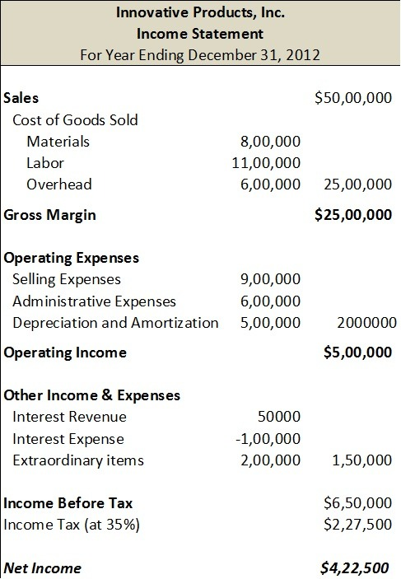

**Class 4**

Business Types

**WEEK 3**

**Class 5**

Feasibility

**Class 6**

Feasibility

**WEEK 4**

**Class 7**

Feasibility

**Class 8**

Feasibility

**WEEK 5**

**Class 9**

Feasibility

**Class 10**

Feasibility

**WEEK 6**

**Class 11**

Feasibility

**Class 12**

Feasibility

**WEEK 7**

**Class 13**

Feasibility

**Class 14**

Feasibility

**WEEK 8**

**Class 15**

Feasibility

**Class 16**

Feasibility

**WEEK 9**

**Class 17**

Feasibility

**Class 18**

Feasibility

**WEEK 10**

**Class 19**

Feasibility

**Class 20**

Feasibility

**VIDEOS**

Paul Graham

https://www.youtube.com/watch?v=2lcp0uZsY7k&t=12s

**PAST**

**Class 3**

Feasibility Analysis

Sharks Tank

Basics of Financials

Go over Project

Go over Presentations

Select Groups (start)

Do a payment cost Analysis

* Stripe
* Paypal
* Square
* Merchant Account
* US Bank
* Wells Fargo

At 19:00

<https://www.youtube.com/watch?v=Z5iNZkVUSOk>

Videos

Tree Props 46:00

<https://www.youtube.com/watch?v=Z5iNZkVUSOk>  
- good financial questions   
working capital = current assets – current liabilities

current assets

* converted to cash within a year
* Three main types
  + Accounts Recievable
  + Inventory
  + Prepaid Expense-

Paul Graham

**WEEK 1**

**Class 1**

**Course Introduction**

* Syllabus
* Lecture 1- Intro to Business Plans

**Class 2**

**Updates**

Peter Theil

<https://www.youtube.com/watch?v=PeVjGpNpF6E>

Paul

https://www.youtube.com/watch?v=2lcp0uZsY7k

Peter

https://www.youtube.com/watch?v=UUzvo4HwojU

**WEEK**

**Class 13**

Sales Mark Cuban

https://www.youtube.com/watch?v=rFls-kcnJxU

Rejection Barbara

<https://www.youtube.com/watch?v=xTffQqscRow>

**WEEK 2**

**Class 13**

Sales Mark Cuban

https://www.youtube.com/watch?v=rFls-kcnJxU

Rejection Barbara

<https://www.youtube.com/watch?v=xTffQqscRow>

**WEEK 8**

**Class 15**

Theranos

<https://www.youtube.com/watch?v=-kbja1EI1kQ>

<https://www.youtube.com/watch?v=VINIbbmI0BU>

Madoff

https://www.youtube.com/watch?v=al5SLsoe0C0

**Notes**

**Gmail**

Email: fall18arec213@gmail.com

Pw: f18arec213

**Dropbox**

First: fall18  
Last: arec213

Email: fall18arec213@gmail.com

Pw: f18arec213

**Week 4**

L7- Finance

L8- Finance

**Week 5**

L9- Finance

L10- Midterm

**Financials**

Lecture 6

Break Even Analysis

Financing your venture

* Debt
* Equity

Lecture 7

Financial Management

Objectives of Firm (profitability, liquidity, efficiency, stability)

Cash Flow

Cash and Accrual Accounting

Lecture 9

Financial Statements

* Income Statement
* Cash Flow
* Balance Sheet

Could Add

* Earnings vs Cash Flow
* Depreciation
* Business Expense
* Taxes (Add to Operations)

**OLD**

**WEEK 4**

**Class 7**

**Updates**

Midterm Reminder

Grades

Career Fair

**Topic**

Break Even Analysis

Financing your Company

Starting a Business

**Review**

Break Even Analysis

Supply and Demand

**Assignments**

Excel- Create a Payment Cost Sheet

* Online
* In Person
* Merchant (Store)
* Cash, Venmo Checks

ICA Excel Assignment

**Class 8**

Slower overview of websites

Group Time

**Class 9**

Balance Sheet

Statement of Cash Flows

Taxes

Depreciation

**Mark Cuban**

https://www.youtube.com/watch?v=KYneLGRTgy8&t=220s

**WEEK 3**

**Class 5**

Online Bonsai

* Company Type
  + http://sos.oregon.gov/business/Pages/starting-business.aspx
* Supply Chain
* Online Vendor
* Grow to Nursery
* Book keeping starters

Groups Overview

* Idea Solidification

Excel Assignment

Economic Systems

Industry Analysis

Bonsai Company Business Type

* Industry
* Market

Dropbox

Go Over my Analysis

**Technology**

Domains

Hosting

Simple Page

Frameworks

**Youtube**

Paul

https://www.youtube.com/watch?v=2lcp0uZsY7k

Peter

https://www.youtube.com/watch?v=UUzvo4HwojU

**Class 6**

Solidify Idea

Start List of Variable and Fixed Costs in Excel

**OTHER**

Note Taker

Web Domain and Hosting

Excel

Go over ICA

4 types of businesses

* Week 2A Lecture_Company_Description (WEEK 2)
* https://www.wellsfargo.com/biz/required-documents/

Statistics

Economics

* Competition and Monopoly

Business types

Barbara

https://www.youtube.com/watch?v=kU1DI8HsYAg&t=239s

**LLC**

<http://sos.oregon.gov/business/Pages/domestic-limited-liability-companies-forms.aspx>

**Oregon Corporate Tax**

http://www.oregon.gov/DOR/programs/businesses/Pages/default.aspx

**Class 4**

Form Groups

Group Time

Note Taker

Web Domain and Hosting

Excel

Go over ICA

4 types of businesses

* Week 2A Lecture_Company_Description (WEEK 2)
* https://www.wellsfargo.com/biz/required-documents/

Statistics

Economics

* Competition and Monopoly

Business types

**Youtube**

Paul

https://www.youtube.com/watch?v=2lcp0uZsY7k

Peter

https://www.youtube.com/watch?v=UUzvo4HwojU

Barbara

https://www.youtube.com/watch?v=kU1DI8HsYAg&t=239s

**LLC**

<http://sos.oregon.gov/business/Pages/domestic-limited-liability-companies-forms.aspx>

**Oregon Corporate Tax**

http://www.oregon.gov/DOR/programs/businesses/Pages/default.aspx

**Stats**

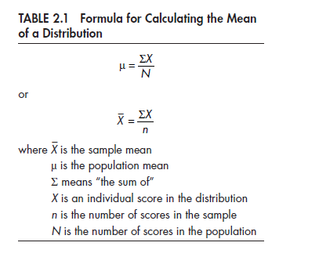

**Econ**

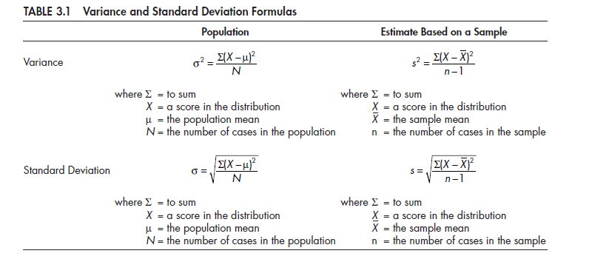

**Perfect Competition**

Perfect competition is a market system characterized by many different buyers and sellers. In the classic theoretical definition of perfect competition, there are an infinite number of buyers and sellers. With so many market players, it is impossible for any one participant to alter the prevailing price in the market. If they attempt to do so, buyers and sellers have infinite alternatives to pursue.

**Monopoly**

A monopoly is the exact opposite form of market system as perfect competition. In a pure monopoly, there is only one producer of a particular good or service, and generally no reasonable substitute. In such a market system, the monopolist is able to charge whatever price they wish due to the absence of competition, but their overall revenue will be limited by the ability or willingness of customers to pay their price.

**Oligopoly**

An oligopoly is similar in many ways to a monopoly. The primary difference is that rather than having only one producer of a good or service, there are a handful of producers, or at least a handful of producers that make up a dominant majority of the production in the market system. While oligopolists do not have the same pricing power as monopolists, it is possible, without diligent government regulation, that oligopolists will collude with one another to set prices in the same way a monopolist would.

**Monopolistic Competition**

Monopolistic competition is a type of market system combining elements of a monopoly and perfect competition. Like a perfectly competitive market system, there are numerous competitors in the market. The difference is that each competitor is sufficiently differentiated from the others that some can charge greater prices than a perfectly competitive firm. An example of monopolistic competition is the market for music. While there are many artists, each artist is different and is not perfectly substitutible with another artist.

**Monopsony**

Market systems are not only differentiated according to the number of suppliers in the market. They may also be differentiated according to the number of buyers. Whereas a perfectly competitive market theoretically has an infinite number of buyers and sellers, a monopsony has only one buyer for a particular good or service, giving that buyer significant power in determining the price of the products produced.

**Class 3**

**Overview**

Recap what we have done

Show Sharks tank

List Ideas

* Feasibility analysis on them

Select Teams

Feasibility Analysis (include lecture on product and selling from 213)

* Week 3 Products and Services Description (WEEK 2)

Websites

**Teaching**

* Recap
  + Small Business
  + Entrepreneurs
  + Ideation
* Excel
* Product and Customer
* Stats Example
* Economics
  + Supply and Demand
* Scaling and business type
  + Tech verse hair salon
* Online
  + Websites and Hosting
* http://www.oregon.gov/business/Pages/toolkit.aspx

cd ~/public_html  
find ./ -type d -exec chmod 755 {} \;  
find ./ -type f -exec chmod 644 {} \;

**Class 5**

Show both videos

* Do they contradict each other

Show my analysis

**Class 2**

**Topic:**

**Assigned Reading:**

**Course Time Schedule:**

* Gathering Together Farm
* Elevator Pitches
  + Video
* Go over ICA
* Do ICA
* Lecture

<http://block15.com/local-and-sustainable#sustainability-practices>

https://www.gatheringtogetherfarm.com/about-gtf